|  |  |  |
| --- | --- | --- |
| **Chapter** | **Title** | **Page No.** |
| 1 | Introduction |  |
| 1.1 | Problem Statement | 1 |
| 1.2 | Objectives | 1 |
| 1.3 | Scope of the Project | 2 |
| 1.4 | Methodology | 2 |
| 1.5 | Organization of the Report | 3 |
| 2 | Literature Survey |  |
| 2.1 | Existing Systems | 4 |
| 2.2 | Limitations of Existing Systems | 5 |
| 2.3 | Proposed System | 5 |
| 3 | System Analysis |  |
| 3.1 | Requirement Analysis | 6 |
| 3.2 | Feasibility Study | 7 |
| 3.3 | Hardware and Software Requirements | 8 |
| 4 | System Design |  |
| 4.1 | System Architecture | 10 |
| 4.2 | Data Flow Diagram | 11 |
| 4.3 | Use Case Diagram | 12 |
| 4.4 | Activity Diagram | 13 |
| 4.5 | Sequence Diagram | 14 |
| 5 | Implementation |  |
| 5.1 | Module Description | 15 |
| 5.1.1 | Fire Detection | 15 |
| 5.1.2 | Smoke Detection | 16 |
| 5.1.3 | Location Tracking | 17 |
| 5.1.4 | Email Notification | 18 |
| 5.2 | User Interface | 19 |
| 6 | Results and Analysis |  |
| 6.1 | Testing | 20 |
| 6.2 | Accuracy Graph | 21 |
| 6.3 | Accuracy vs. Loss Graph | 22 |
| 6.4 | Observations | 23 |
| 7 | Conclusion and Future Work |  |
| 7.1 | Conclusion | 24 |
| 7.2 | Future Enhancements | 25 |
| 8 | References | 26 |
| 9 | Appendices |  |
| 9.1 | Code Listings | 28 |
| 9.2 | Sample Email Notification | 29 |

**Table of Content with Sub-Chapter**

**Chapter with Sub-Chapter**

## List of Figures

|  |  |  |
| --- | --- | --- |
| **Figure** | **Title** | **Page No.** |
| 4.1 | System Architecture Diagram | 10 |
| 4.2 | Data Flow Diagram (Level 0) | 11 |
| 4.3 | Use Case Diagram | 12 |
| 4.4 | Activity Diagram | 13 |
| 4.5 | Sequence Diagram | 14 |
| 6.1 | Accuracy Graph | 21 |
| 6.2 | Accuracy vs. Loss Graph | 22 |
| 9.2 | Email Notification Sample | 29 |

## List of Tables

|  |  |  |
| --- | --- | --- |
| **Table** | **Title** | **Page No.** |
| 3.1 | Hardware Requirements | 8 |
| 3.2 | Software Requirements | 9 |
| 6.1 | Accuracy Results | 21 |
| 6.2 | Test Case Summary | 22 |

**ABSTRACT**

Fire accidents pose a significant threat to lives, property, and the environment, necessitating the development of efficient and accurate fire detection systems. Traditional fire detection methods, such as smoke and heat detectors, often suffer from delays and false alarms, limiting their effectiveness in real-time applications. To address these limitations, this study explores the integration of sensor-based fire detection with Machine Learning (ML) techniques to enhance accuracy, speed, and reliability.

This research focuses on using multiple sensors, such as temperature, gas, humidity, and infrared sensors, to collect real-time environmental data. These sensors provide a comprehensive dataset that reflects various fire indicators, such as a sudden rise in temperature, smoke presence, or changes in air composition. The collected data is then processed using ML algorithms to classify fire incidents accurately while reducing false positives caused by non-fire conditions. The use of Internet of Things (IoT) technology allows seamless data transmission to a centralized system, enabling remote monitoring and proactive fire prevention measures. Furthermore, cloud computing integration ensures efficient data storage, analysis, and accessibility from anywhere, allowing for large-scale implementation across multiple locations.

Different ML models, including Decision Trees, Support Vector Machines (SVM), Random Forest, and Neural Networks, are trained on historical fire and non-fire data. The performance of these models is evaluated based on key metrics such as accuracy, precision, recall, and F1-score. Additionally, techniques such as feature engineering, hyperparameter tuning, and ensemble learning are employed to improve model robustness and efficiency. The model with the best performance is integrated into a real-time monitoring system capable of sending instant alerts to emergency responders when a fire is detected. The system can also be linked to automated fire suppression mechanisms, further minimizing fire-related damages.

To further improve reliability, this study investigates the effectiveness of sensor fusion techniques, where multiple sensor readings are combined to create a more accurate and comprehensive fire detection model. This multi-modal approach enhances decision-making by reducing uncertainty and improving prediction accuracy. Moreover, real-time anomaly detection mechanisms are incorporated to differentiate between normal environmental changes and actual fire incidents, reducing the likelihood of false alarms.

The proposed system enhances fire detection efficiency by leveraging ML’s predictive capabilities, allowing for faster and more reliable fire detection compared to traditional methods. Additionally, it minimizes the chances of false alarms, ensuring that emergency responses are more targeted and effective. The implementation of this system has the potential to revolutionize fire safety by providing intelligent, data-driven, and real-time fire detection solutions.

**CHAPTER- 1**

**1.1 Literature Survey**

E-Swara Technologies is a dynamic and forward-thinking technology solutions company that has been driving innovation since its establishment in 2016. With a strong foothold in software development, IT consulting, and digital transformation, the company has positioned itself as a leader in providing comprehensive, end-to-end technology solutions for businesses across various industries.

The company’s journey began with a mission to revolutionize how businesses integrate technology into their operations. Over the years, E-Swara Technologies has consistently adapted to the fast-paced evolution of the tech landscape, ensuring their clients stay competitive, efficient, and future-ready.

What sets E-Swara Technologies apart is its commitment to customer-centric innovation. By closely understanding the unique needs of each client, the company delivers customized solutions designed to optimize performance, streamline operations, and enable sustainable growth. Whether working with small businesses or large multinational corporations, E-Swara Technologies tailors its services to fit the specific goals and challenges of each organization.

E-Swara Technologies also prides itself on fostering a culture of continuous learning and adaptation. The team regularly explores emerging technologies such as artificial intelligence, cloud computing, data analytics, and the Internet of Things (IoT) to ensure their clients benefit from cutting-edge innovations.

With a highly skilled workforce, robust technology expertise, and a strong focus on delivering excellence, E-Swara Technologies continues to expand its footprint in the technology solutions market. The company’s unwavering dedication to empowering businesses with digital transformation has earned it a trusted reputation among clients both in India and overseas.

In a world driven by technology, E-Swara Technologies stands as a reliable partner, helping businesses navigate digital disruption, achieve operational efficiency, and unlock new opportunities for growth and success.

**1.2 Why Choose E-Swara Technologies?**

* Technology Solutions Provider: Offers a comprehensive range of IT services, from software development to digital transformation.
* Customer-Centric Approach: Prioritizes understanding client requirements to deliver tailored solutions.
* Focus on Innovation: Implements emerging technologies like cloud computing, data analytics, and automation.
* End-to-End Services: Provides complete solutions from consultation to post-deployment support.
* Industry Agnostic: Serves SMEs and large corporations alike with scalable solutions.

**1.3 Vision and Mission**

**Vision**

* Driving Digital Transformation: Aims to lead in innovative technology solutions, helping businesses improve efficiency and competitiveness.
* Customer-Centric Innovation: Designs tailored technology solutions to empower clients in the evolving digital landscape.
* Sustainable Growth: Focuses on growth through emerging technologies and long-term client partnerships.

**Mission**

* Delivering Innovative Solutions: Provides tailored technology services to promote growth and digital transformation.
* Empowering Clients: Helps businesses leverage technology to optimize operations and achieve success.
* Commitment to Excellence: Ensures high-quality, scalable IT services aligned with client needs.
* Continuous Learning & Adaptation: Stays ahead of technology trends to foster innovation.

**1.4 Company Operation Domains**

* Software Development
* IT Consulting
* Cloud Computing
* Data Analytics
* Business Automation
* ERP & CRM Systems
* Machine Learning & AI
* Internet of Things (IoT)
* Embedded Systems

**1.5 Clients and Partnerships**

E-Swara Technologies collaborates with SMEs, large corporations, and multinational companies, offering customized solutions across multiple industries.

**1.6 Company Organization Structure**

* Chief Executive Officer (CEO): Leads strategic direction and performance.
* Chief Technology Officer (CTO): Manages technology innovations and solutions.
* Chief Operating Officer (COO): Handles daily operations for productivity and efficiency.
* Chief Financial Officer (CFO): Manages budgeting and financial stability.
* Sales & Marketing Leaders: Drive business growth and client relationships.
* Project Managers: Oversee project timelines, budgets, and delivery.
* ****HR & Talent Management: Handle recruitment, development, and company culture.

**Fig 1.1**Organization Structure

**1.7 Roles and Responsibilities of Personnel**

* CEO: Strategic leadership and performance oversight.
* CTO: Technological direction, development, and innovation.
* COO: Operational management, productivity optimization.
* CFO: Financial planning and stability.
* Sales & Marketing: Client relationships, business growth.
* Project Managers: Ensure project delivery within time and budget.
* HR: Recruitment, training, and maintaining organizational culture.

**1.8 Product and Market Performance**

E-Swara Technologies has established itself as a leader in recruitment and technology development, working with clients across various sectors to implement digital solutions that drive growth, improve efficiency, and enhance competitiveness.

**1.9 Strengths**

* Skilled Workforce: Experienced professionals across technology domains.
* Customized Solutions: Tailored services based on client needs.
* Focus on Innovation: Uses AI, cloud computing, and data analytics to stay ahead.
* Comprehensive Service Offerings: Consulting, development, and post-deployment support.
* Customer-Centric Approach: Builds long-term client relationships.
* Scalable Solutions: Supports businesses from startups to large enterprises.
* Agile Methodology: Enables faster delivery and adaptability.
* Industry Expertise: Provides specialized solutions for diverse sectors.
* Commitment to Quality: Ensures reliable, efficient, and high-value solutions.

**1.10 Tools and Technologies**

**Software Development**

* Languages: Java, Python, C#, PHP, JavaScript, TypeScript, Ruby.
* Web Development: HTML5, CSS3, React.js, Angular, Node.js.
* Mobile Development: Swift, Kotlin, React Native, Flutter.

**Backend**

* Frameworks: Django, Spring, Laravel, .NET.

**Cloud Computing**

* Platforms: AWS, Azure, Google Cloud
* Serverless Architectures: AWS Lambda, Azure Functions
* Storage: AWS S3, Google Cloud Storage

**ERP & CRM Systems**

* ERP: SAP, Microsoft Dynamics 365
* CRM: Salesforce, HubSpot

**Machine Learning & AI**

* Frameworks: TensorFlow, PyTorch, Scikit-Learn, Keras
* Tools: Jupyter Notebook, Pandas, NumPy, Matplotlib

**Internet of Things (IoT)**

* Platforms: AWS IoT, Google Cloud IoT, Azure IoT
* Hardware: Raspberry Pi, Arduino
* Protocols: MQTT, CoAP, Zigbee, LoRaWAN

**1.11 Ongoing Projects**

* DVision Plus: Hotel management software for front office, inventory, accounts, and more.
* DVision Premier: High-end hotel automation software with smart card, power management, SMS, and total integration.
* DRMS: Resort management software covering all resort operations.
* Pay Eazy: Payroll and personnel system for small-scale industries, customizable for larger companies.
* DShoppee: Retail management software with billing, inventory, barcode, and stock management features.
* DPos: Touch-enabled POS software for fast food chains like KFC and Pizza Hut, with direct kitchen billing integration.
* Process Inspection Application: For streamlined manufacturing and operational process monitoring.

**1.12 Services**

* Software Development
* IT Infrastructure Consulting
* Cloud Computing Solutions
* Business Automation
* ERP & CRM Implementation
* AI & Machine Learning Development
* IoT Solutions
* Embedded Systems Development

**1.13 Future Goals**

* Expand service offerings in AI, blockchain, and cybersecurity.
* Enhance digital transformation solutions for small and mid-sized businesses.
* Strengthen client partnerships through customized, scalable technology solutions.
* Promote sustainable growth through innovation and emerging technologies.
* Invest in employee training to stay ahead of evolving technology trends.

**CHAPTER 2**

**2.1 Deep Learning**

Deep Learning is a subset of Machine Learning that utilizes artificial neural networks to model and process complex patterns in data. Unlike traditional machine learning methods, deep learning models can automatically learn representations from raw data without requiring manual feature extraction. This capability has revolutionized various fields, including computer vision, natural language processing, and robotics. By leveraging multiple layers of interconnected neurons, deep learning models can learn hierarchical representations of data, leading to more accurate predictions and decision-making.

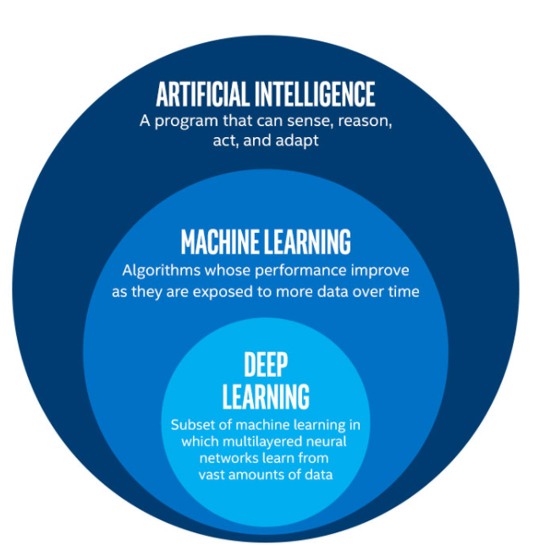Deep learning has gained significant popularity due to its ability to process massive amounts of data efficiently. With the advent of big data and the availability of high-performance computing resources, deep learning models have become more effective in solving real-world problems. The field has expanded rapidly, influencing industries such as healthcare, finance, and entertainment, making AI-driven solutions more prevalent in everyday life.

**Fig 2.1** Deep Learning

**2.2 History and Evolution of Deep Learning**

Deep Learning has its roots in artificial neural networks, which were first conceptualized in the 1940s. The field gained traction in the 1980s with the development of backpropagation, allowing efficient training of multi-layer networks. However, due to computational limitations, deep learning remained largely theoretical until the early 2000s. The advent of powerful GPUs, large-scale datasets, and improved optimization techniques has fueled the rapid advancements in deep learning, making it a dominant force in AI research today. More recently, advancements such as self-supervised learning and transfer learning have further accelerated its impact across various industries.

**2.3 Key Concepts in Deep Learning**

**2.3.1 Artificial Neural Networks (ANNs)**

ANNs are computational models inspired by the structure and function of biological neural networks. They consist of interconnected nodes (neurons) arranged in layers: input, hidden, and output layers. Each neuron processes input signals using weighted connections, applies an activation function, and produces an output. The deeper the network (i.e., the more hidden layers it has), the more complex patterns it can learn.

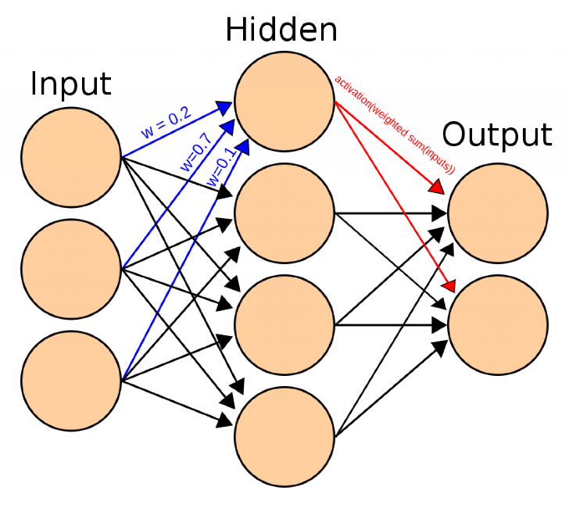

**Fig 2.2**Artificial Neural Networks

**2.3.2 Activation Functions**

Activation functions introduce non-linearity into neural networks, allowing them to learn complex patterns.

* **Sigmoid:** An S-shaped curve that maps inputs between 0 and 1, useful for binary classification but suffers from vanishing gradient problems.
* **ReLU (Rectified Linear Unit):** The most widely used activation function in deep learning, which outputs zero fornegative inputs and remains linear for positive inputs, helping mitigate vanishing gradients.
* **Tanh:** Similar to sigmoid but centered around zero, making it useful in some deep networks.
* **Softmax:** Used in multi-class classification problems to normalize outputs into probability distributions.

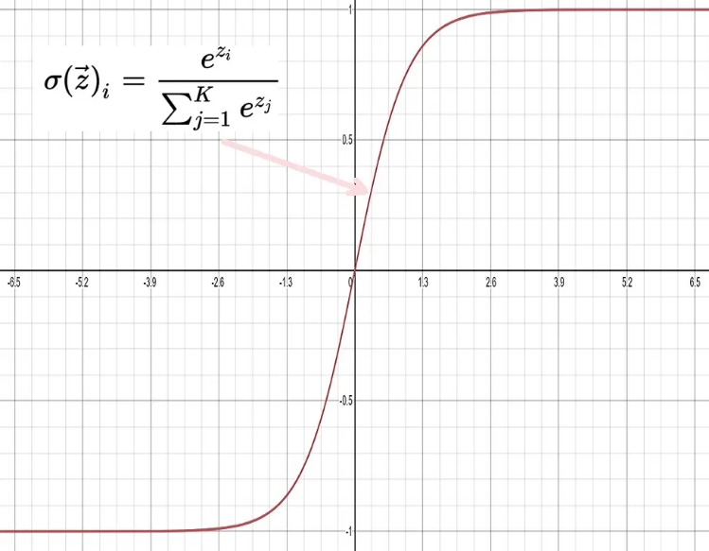

**Fig 2.3**Activation Function

**2.3.3 Loss Functions**

Loss functions measure the difference between predicted and actual outputs, guiding the optimization process.

* **Mean Squared Error (MSE):** Used in regression tasks to measure average squared differences between predicted and actual values.
* **Cross-Entropy Loss:** Common in classification tasks, measuring the distance between predicted probabilities and actual labels.
* **Huber Loss:** Used when dealing with outliers in regression problems, combining benefits of MSE and Mean Absolute Error (MAE).

**2.3.4 Optimizers**

* **Gradient Descent:** A fundamental optimization algorithm that updates weights based on the gradient of the loss function.
* **Stochastic Gradient Descent (SGD):** A variation of gradient descent that updates weights based on a random subset of the training data to improve efficiency.
* **Adam (Adaptive Moment Estimation):** Combines benefits of SGD and RMSProp, adapting learning rates dynamically to accelerate training.

**2.3.5 Regularization Techniques**

Regularization helps prevent overfitting in deep learning models.

* **L1 and L2 Regularization:** Adds penalties to large weights, encouraging simpler models.
* **Dropout:** Randomly drops neurons during training to improve generalization and prevent reliance on specific neurons.
* **Batch Normalization:** Normalizes layer inputs to stabilize learning, improving training speed and model performance.

**2.3.6 Hyperparameter Tuning**

Hyperparameter tuning is crucial for optimizing deep learning models.

* **Learning Rate:** Controls the step size of weight updates; too high can cause instability, too low can slow training.
* **Batch Size:** Determines the number of samples processed before updating model parameters, affecting memory usage and convergence speed.
* **Number of Epochs:** Represents the number of times the training algorithm passes through the dataset; too many can lead to overfitting.

**2.4 Popular Deep Learning Architectures**

**2.4.1ConvolutionaNeural Networks (CNNs)**

CNNs are widely used in image processing tasks. They employ convolutional layers that use filters to capture spatial hierarchies in data, making them effective for tasks such as image classification, object detection, and facial recognition. CNNs reduce the number of parameters by sharing weights, leading to more efficient computations.

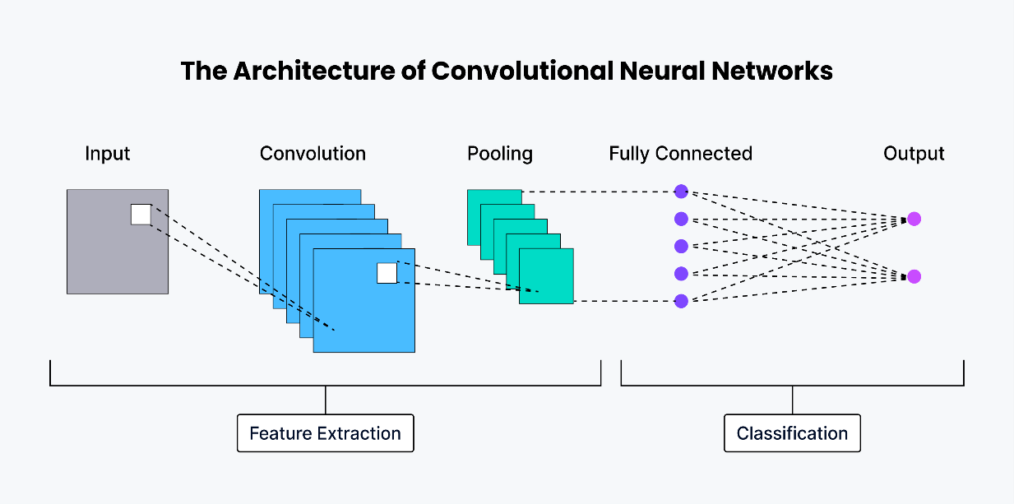

**Fig 2.4**Convolutional Neural Networks

* **Convolutional Layers:**Extract important features such as edges, textures, and patterns.
* **Pooling Layers:**Reduce the size of feature maps, making the model computationally efficient.
* **Fully Connected Layers:**Classify the extracted features and produce final predictions.Popular CNN architectures like AlexNet, VGG, ResNet, and EfficientNet have shown remarkable success in species identification

**2.4.2 Recurrent Neural Networks (RNNs)**

RNNs are designed for sequential data processing, making them well-suited for tasks such as speech recognition, time-series forecasting, and natural language processing. They have feedback loops that allow information persistence, but they suffer from vanishing gradients. Long Short-Term Memory (LSTM) and Gated Recurrent Units (GRUs) help mitigate this issue.

**2.4.3 Transformers**

Transformers, such as the attention-based architecture introduced in "Attention Is All You Need," have revolutionized NLP tasks. They replace RNNs by using self-attention mechanisms to process entire sequences simultaneously, leading to more efficient training and improved performance in models like BERT and GPT.

**2.4.4 Generative Adversarial Networks (GANs)**

GANs consist of two neural networks, a generator and a discriminator, that compete against each other to generate realistic data. GANs are used for image synthesis, style transfer,and creating synthetic datasets for training AI models when real data is scarce.

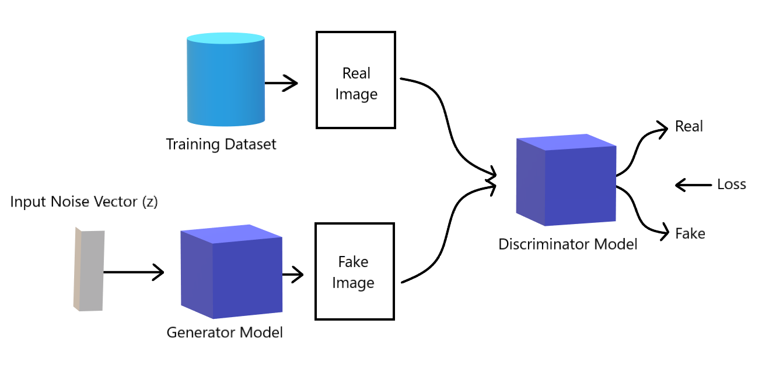

**Fig 2.5**Generative Adversarial Networks

**2.4.5 Autoencoders**

Autoencoders are neural networks designed for unsupervised learning tasks such as anomaly detection and dimensionality reduction. They consist of an encoder that compresses input data into a lower-dimensional representation and a decoder that reconstructs the original input. Variational Autoencoders (VAEs) and Denoising Autoencoders improve their generative capabilities.

**2.5 Applications of Deep Learning**

* **Computer Vision:** Object detection, image classification, facial recognition, medical imaging.
* **Natural Language Processing (NLP):** Chatbots, sentiment analysis, machine translation, text generation.
* **Healthcare:** Disease diagnosis, personalized medicine, drug discovery, medical image analysis.
* **Autonomous Vehicles:** Self-driving cars use deep learning for perception, lane detection, and obstacle avoidance.
* **Finance:** Fraud detection, algorithmic trading, credit risk assessment.
* **Robotics:** Enables robots to perform complex tasks like grasping objects, industrial automation, and autonomous navigation.
* **Agriculture:** Crop monitoring, pest detection, yield prediction, and precision farming.

**2.6 Challenges in Deep Learning**

* **Data Dependency:** Requires vast amounts of labeled data for effective training.
* **Computational Cost:** High-performance GPUs and significant resources are necessary for training deep models.
* **Interpretability:** Often considered a "black-box," making it difficult to explain predictions.
* **Ethical Concerns:** Potential biases in training data can lead to unfair or harmful outcomes.
* **Adversarial Attacks:** Carefully crafted inputs can manipulate models into making incorrect predictions.
* **Scalability:** Training and deploying large models can be expensive and energy-intensive.

**2.7 Future of Deep Learning**

Future research is focused on:

* **Explainable AI (XAI):** Improving interpretability of deep learning models.
* **Federated Learning:** Privacy-preserving decentralized learning.
* **Neural Architecture Search (NAS):** Automating network design.
* **Edge AI:** Running deep learning models on low-power devices.
* **Quantum AI:** Exploring quantum computing for AI advancements.

**CHAPTER 3**

**3.1. Literature Survey**

Fire accidents pose a significant threat to human life and property. Traditional fire detection systems, such as smoke detectors and infrared sensors, are commonly used but often suffer from false alarms and delayed response times. With advancements in artificial intelligence, machine learning (ML) and deep learning (DL) models are increasingly being used to enhance fire detection accuracy. This literature survey explores existing fire detection methodologies and their effectiveness in real-time applications.

**3.2.Traditional Fire Detection Methods**

Early fire detection relied on physical sensors like smoke, temperature, and gas detectors. While these systems are effective in controlled environments, they often fail in open spaces or require high maintenance. Image-based fire detection methods emerged as an alternative, leveraging computer vision techniques to analyze fire patterns from images or videos. These traditional methods include:

* **Smoke Sensors:**Detect changes in air quality but may not be effective outdoors.
* **Heat Sensors:**Require high temperatures to trigger an alarm, leading to delayed responses.
* **Infrared Sensors:** Identify heat signatures but can be expensive and require calibration.

While these methods remain in use, their limitations have driven the adoption of more advanced image-processing and AI-based fire detection techniques.

**3.3.Image Processing-Based Fire Detection**

Traditional computer vision approaches use handcrafted features such as color-based segmentation, edge detection, and motion analysis to identify fire. Methods such as:

* **RGB and HSV color space analysis** for fire-like color segmentation.
* **Optical flow techniques** to detect flame movement.
* **Background subtraction**for detecting fire against static backgrounds.
* **Wavelet transform and texture analysis** to extract fire-relevant features.

Although effective in controlled conditions, these approaches suffer from high false positives due to similar-colored objects like sunset, artificial lighting, or reflective surfaces. They also struggle with distinguishing fire from similar-looking objects in dynamic backgrounds.

**3.4 Machine Learning for Fire Detection**

Machine learning models offer an improvement over rule-based methods by leveraging pattern recognition and feature extraction. Several supervised learning algorithms have been used for fire detection, including:

* **Support Vector Machines (SVM):** Classifies fire based on extracted image features.
* **Random Forest and Decision Trees:** Used for fire region classification by analyzing multiple decision paths.
* **K-Nearest Neighbors (KNN):**Identifies fire patterns by comparing new instances with existing labeled data.
* **Bayesian Networks:**Probabilistic models that improve detection confidence by incorporating prior knowledge.

These models require a labeled dataset for training and may struggle with dynamic environmental changes, leading to misclassification in certain scenarios. Hybrid approaches that combine multiple machine learning techniques are being explored to enhance robustness.

3.5 **Deep Learning Approaches**

With the rise of deep learning, convolutional neural networks (CNNs) and other architectures have demonstrated high accuracy in fire detection. Some notable works include:

* **CNN-based fire classifiers** trained on large datasets of fire and non-fire images.
* **Recurrent Neural Networks (RNNs) and Long Short-Term Memory (LSTM) networks** for analyzing temporal fire patterns in videos.
* **Transfer learning using pre-trained models** like VGG16, ResNet, and MobileNet for faster and more accurate fire detection.
* **Autoencoders and Generative Adversarial Networks (GANs):** Used to enhance fire detection datasets and improve model generalization.

Deep learning methods significantly outperform traditional techniques by learning hierarchical features automatically but require substantial computational resources. Cloud computing and edge AI solutions are being integrated to mitigate hardware limitations.

**3.6Real-Time Fire Detection Systems**

Real-time fire detection systems integrate deep learning with hardware components, such as cameras and IoT devices, to provide rapid alerts. Some real-world implementations include:

* **Drone-based fire monitoring**using CNNs for early wildfire detection.
* **Embedded AI models on Raspberry Pi or Jetson Nano**for edge-based fire detection.
* **Integration with cloud-based services** for remote fire monitoring and alerting.
* **IoT-based smart fire alarms** that combine sensor data with AI-powered image analysis.

These systems enhance response times but may face challenges related to data privacy, latency, and hardware limitations. Future advancements aim to make these systems more energy-efficient and scalable for widespread deployment.

**3.7Challenges and Future Directions**

Despite advancements in AI-driven fire detection, several challenges remain:

* **False Positives and Negatives:**Fire-like colors and reflections can trigger false alarms, while small or distant fires may go undetected.
* **Computational Overhead:**Deep learning models require powerful GPUs for training and real-time inference.
* **Dataset Limitations:**Publicly available fire datasets may not cover diverse environmental conditions, leading to biased models.
* **Environmental Variability:**Weather conditions such as fog, rain, and smoke can affect model accuracy.
* **Integration with Existing Systems:** Deploying AI-based fire detection in legacy fire alarm systems requires compatibility solutions.

Future research should focus on improving dataset diversity, optimizing lightweight AI models for real-time applications, and developing hybrid detection approaches that combine sensor data with image-based analysis. The use of explainable AI (XAI) techniques can also help improve the interpretability of deep learning models in fire detection.

* **Multispectral and Hyperspectral Imaging:**Using different wavelengths to enhance fire detection accuracy.
* **Federated Learning Approaches:**Allowing multiple devices to collaboratively improve fire detection models without sharing sensitive data.
* **Blockchain for Fire Detection Logs:**Ensuring the integrity of fire detection records and facilitating reliable fire incident reporting.
* **Enhanced Edge AI Processing:** Reducing the need for cloud dependence by processing fire detection models directly on low-power devices.
* **Self-Adaptive AI Models:**Implementing models that continuously learn from new fire incidents and dynamically adjust their parameters to improve detection accuracy in real-world environments.
* **Sensor Fusion Techniques:**Combining data from multiple sources, such as thermal cameras, gas sensors, and satellite imagery, to enhance fire detection accuracy and reliability.
* **Automated Fire Response Systems:** Developing AI-driven robotic systems that can autonomously navigate towards fire incidents and initiate firefighting measures.
* **Explainable AI (XAI) for Fire Detection:**Improving model transparency and interpretability to ensure trust in AI-based fire detection decisions.
* **Cybersecurity Measures in AI-Based Fire Detection:** Ensuring AI-driven fire detection systems are protected from cyber threats, preventing malicious attacks that could disable or manipulate fire detection functionalities.

**3.8Ethical and Regulatory Considerations**

With AI-driven fire detection becoming more widespread, ethical and legal concerns need to be addressed:

* **Data Privacy and Security:**Fire detection systems involving surveillance cameras must adhere to privacy regulations to prevent misuse.
* **Bias in AI Models:**Ensuring that fire detection models do not exhibit biases due to underrepresentation of certain environmental conditions in training datasets.
* **Regulatory Approvals:**Compliance with government regulations for AI-based fire detection systems to ensure safety and reliability.
* **Liability Issues:**Determining responsibility in case of AI system failures leading to undetected fires or false alarms.

**CHAPTER- 4**

**4.1. Project Manager**

**Responsibilities:**

* Define project scope, objectives, and deliverables.
* Develop detailed project plans, schedules, and timelines.
* Allocate resources effectively and manage budgets.
* Monitor and report project progress to stakeholders.
* Ensure risk management strategies are in place.
* Foster collaboration among team members.
* Resolve conflicts and provide leadership guidance.
* Ensure projects are completed on time and within scope.
* Conduct regular team meetings to track progress.
* Implement process improvements to enhance project efficiency.
* Establish key performance indicators (KPIs) to measure project success.
* Liaise with vendors, clients, and stakeholders to ensure alignment.
* Develop contingency plans to mitigate potential risks.

**Skills**

* Strong leadership and decision-making abilities.
* Excellent communication and interpersonal skills.
* Proficiency in project management tools (e.g., MS Project, Jira, Trello).
* Risk assessment and problem-solving skills.
* Time management and multitasking capabilities.
* Budgeting and financial management knowledge.
* Adaptability to changing project requirements.
* Negotiation and stakeholder management skills.
* Knowledge of Agile and Scrum methodologies.

**4.2. Software Developer**

**Responsibilities:**

* Write, test, and maintain high-quality code.
* Develop software solutions based on client and team specifications.
* Collaborate with designers, analysts, and testers.
* Debug and troubleshoot software issues.
* Implement security measures and ensure software scalability.
* Stay updated with emerging technologies and best practices.
* Participate in code reviews and continuous improvement processes.
* Optimize application performance and scalability.
* Ensure software documentation is up to date.
* Contribute to team discussions on technology choices.
* Develop APIs and integrate third-party services.
* Work with cloud platforms to enhance software deployment.
* Implement machine learning algorithms where applicable.

**Skills**

* Proficiency in programming languages (e.g., Python, Java, C++).
* Knowledge of software development methodologies (Agile, Scrum, Waterfall).
* Strong problem-solving and analytical skills.
* Experience with databases and version control systems (e.g., Git, SQL).
* Ability to work both independently and in a team environment.
* Attention to detail and ability to write clean, maintainable code.
* Experience with cloud computing and DevOps practices.
* Understanding of cybersecurity principles and secure coding practices.
* Ability to develop mobile and web applications.

**4.3. Marketing Specialist**

**Responsibilities:**

* Develop and implement marketing campaigns.
* Conduct market research and analyze trends.
* Manage social media, content creation, and email marketing.
* Collaborate with the sales team to align strategies.
* Monitor and report on campaign performance and ROI.
* Establish brand positioning and manage brand consistency.
* Identify new business opportunities and partnerships.
* Create engaging content tailored for different platforms.
* Develop and track KPIs to measure campaign success.
* Optimize marketing strategies based on data analytics.
* Implement automation tools for email and content marketing.
* Conduct customer segmentation to personalize marketing efforts.
* Organize and promote webinars, events, and influencer collaborations.

**Skills**

* Strong understanding of digital marketing strategies.
* Experience with SEO, SEM, and social media marketing.
* Excellent analytical and research skills.
* Strong communication and creativity.
* Proficiency in marketing tools (e.g., Google Analytics, HubSpot, Mailchimp).
* Ability to work under pressure and meet deadlines.
* Knowledge of customer behavior and market segmentation.
* Expertise in conversion rate optimization and A/B testing.
* Experience with pay-per-click (PPC) advertising.

**4.4. Human Resources Manager**

**Responsibilities:**

* Develop and enforce company policies and culture.
* Manage recruitment, onboarding, and employee relations.
* Oversee performance management and professional development.
* Ensure compliance with labor laws and company regulations.
* Handle conflict resolution and employee concerns.
* Implement employee engagement and retention strategies.
* Coordinate with management for workforce planning.
* Design and execute training and development programs.
* Monitor and enhance employee satisfaction and workplace morale.
* Develop succession planning strategies for key roles.
* Conduct diversity and inclusion training.
* Implement HR analytics to improve workforce efficiency.
* Manage compensation and benefits administration.

**Skills**

* Strong interpersonal and communication skills.
* Knowledge of labor laws and HR best practices.
* Proficiency in HR software and management tools.
* Conflict resolution and problem-solving abilities.
* Ability to handle sensitive and confidential information.
* Organizational and time management skills.
* Leadership and team-building expertise.
* Understanding of compensation and benefits structures.
* Experience in talent acquisition and performance evaluation.

**CHAPTER- 5**

**5.1. Project**

Fire is one of the most destructive disasters, often resulting in severe loss of life, property, and infrastructure. It spreads rapidly and can be challenging to control, making early detection crucial in minimizing damage. Traditional fire detection systems primarily rely on smoke sensors and heat detectors, which typically trigger alarms only after the fire has already produced significant heat or smoke. This delay can lead to extensive destruction before any suppression measures are activated. Additionally, conventional systems may not be effective in large open spaces or areas with high air circulation, where smoke dispersion reduces sensor efficiency.

To address these limitations, this project presents an advanced, AI-powered fire detection system that leverages computer vision techniques using OpenCV, multi-threading for efficient processing, and automated email notifications for real-time alerts. The system utilizes a live video feed from a webcam to monitor an environment continuously. A pre-trained Haar Cascade model is used to detect fire by analyzing visual patterns, enabling a rapid response mechanism. Instead of relying solely on motion-based or thermal-based detection, the system integrates a color-based confidence scoring method to enhance accuracy while reducing false positives caused by similar-colored objects like lights or reflections.

By implementing multi-threading, the system ensures smooth operation without performance bottlenecks. Detection, alert triggering, and data processing run concurrently, preventing any lag or delays in identifying potential fire hazards. Additionally, the system generates graphical reports, displaying fire detection trends over time. This analytical capability allows users to review historical data, assess potential risk patterns, and implement improved fire safety strategies.

The AI-powered fire detection system is designed for diverse applications, including residential buildings, office spaces, warehouses, and industrial settings. Its ability to provide real-time alerts through audible alarms and instant email notifications enhances situational awareness, allowing quicker action to mitigate fire-related risks. By combining artificial intelligence, computer vision, and automation, this system presents a reliable and efficient solution for modern fire safety management.

The system is also adaptable, allowing integration with smart home automation and IoT-based fire safety networks for enhanced protection. It can be deployed in remote locations where manual fire monitoring is challenging, ensuring continuous surveillance. The use of AI-driven pattern recognition minimizes the chances of sensor malfunctions, making it a more robust alternative to conventional methods. Additionally, the system can be expanded to incorporate thermal imaging for even greater detection accuracy. With its scalable and modular design, it can be customized for various environments, making fire detection more proactive and efficient.

**5.2. Objectives**

1. **Developing an AI-driven real-time fire detection system –** The system utilizes computer vision techniques, including Haar Cascade classifiers and color-based detection, to accurately identify fire in live video feeds. The AI model is trained to differentiate fire from other moving or bright objects, ensuring reliable detection.
2. **Implementing an automated alert mechanism** – Upon detecting fire, the system triggers an immediate response by activating an alarm sound and sending an email notification to designated recipients. This ensures that the appropriate authorities or individuals are alerted in real-time, allowing faster intervention.
3. **Enhancing fire detection accuracy** – The system incorporates a confidence threshold using HSV (Hue, Saturation, Value) colour segmentation, allowing it to distinguish actual fire from objects with similar colours, such as sunlight, bright clothing, or artificial lights. By refining detection algorithms, false alarms are minimized, leading to more precise identification.
4. **Ensuring real-time performance with multi-threading –** Multi-threading is used to run various processes simultaneously without affecting overall system efficiency. This means that while fire detection is occurring, alerts (sound and email notifications) can be triggered concurrently without causing lag or slowing down video processing.
5. **Providing graphical analysis of fire detection trends –** The system logs each fire detection event and presents the data through visual tools such as line graphs, histograms, and moving averages. This analysis helps users identify patterns, assess high-risk periods, and take preventive measures accordingly.
6. **Minimizing false positives –** By continuously tuning fire detection parameters and testing under different environmental conditions, the system reduces misidentifications. Additional filters, such as motion detection and adaptive thresholding, further improve accuracy and ensure that alerts are only triggered by actual fire incidents.
7. **Scalability and adaptability –** Designed for flexibility, the system can be deployed in diverse environments such as homes, offices, warehouses, and industrial facilities. It does not require specialized hardware and can function with standard webcams and computing devices, making it cost-effective and accessible.
8. **Developing an intuitive and user-friendly interface –** The system features a graphical user interface (GUI) displaying real-time fire detection status, confidence levels, and alert logs. The interface is designed to be simple and easy to navigate, ensuring that users with minimal technical knowledge can operate the system efficiently.
9. **Integrating cloud-based logging (future enhancement) –** A planned feature is the ability to store fire detection data in a cloud database. This would allow remote monitoring, data backup, and advanced analytics to help organizations track fire incidents over time and improve their fire safety strategies.
10. **Improving emergency response –** By reducing detection time and enabling instant notifications, the system aids in quicker decision-making and emergency response activation. Faster alerts mean that fire suppression measures, such as sprinklers or fire department intervention, can be deployed sooner, preventing significant damage and potential loss of life.

**5.3. System Architecture**

* The fire detection system consists of multiple software and hardware components working together to enable real-time fire detection, alert generation, and data visualization. The system is designed for efficiency, accuracy, and responsiveness, ensuring minimal delays in detecting fire hazards.

**Key Components**

1. **OpenCV (Open Source Computer Vision Library)** – OpenCV is the core library used for image processing and fire detection. It enables real-time processing of video frames captured from a webcam or an external camera. The system uses pre-trained Haar Cascade classifiers and HSV (Hue, Saturation, Value) color-based segmentation to detect fire in the video feed.
2. **Threading** – Multi-threading ensures that the system can handle multiple tasks simultaneously. While one thread processes the video frames for fire detection, other threads manage alert mechanisms, such as triggering alarms and sending email notifications. This prevents delays and keeps the system responsive.
3. **Playsound** – A lightweight Python library responsible for playing an alert sound whenever fire is detected. This immediate auditory warning helps users react quickly to potential fire threats.
4. **SMTP Library** – The Simple Mail Transfer Protocol (SMTP) library is used for sending automated email notifications to predefined recipients when fire is detected. The system can be configured to send alerts to fire safety personnel, building managers, or homeowners.
5. **Matplotlib & NumPy** – These libraries are used for graphical analysis and visualization of fire detection trends. NumPy handles data manipulation, while Matplotlib generates line graphs, histograms, and moving averages, helping users understand fire occurrence patterns over time.

**System Workflow**

1. **Video Frame Capture** – The camera continuously captures video frames and sends them to the processing module.
2. **Preprocessing** – The frames are converted into grayscale (for Haar Cascade detection) and HSV color space (for color-based segmentation).
3. **Fire Detection** – The system applies the Haar Cascade model and HSV filtering to identify fire-like regions in the frame.
4. **Confidence Score Calculation** – If a detected region matches fire-like features with high confidence, the system validates it as an actual fire event.
5. **Triggering Alerts** – If fire is confirmed:
   * An alarm sound is played.
   * An email notification is sent to predefined recipients.
6. **Data Logging and Analysis** – Detection events are recorded for further review. Graphical representations of detection trends are generated.
7. **Continuous Monitoring** – The system runs in a continuous loop, ensuring real-time monitoring without interruptions.

**System Features and Enhancements**

* **Low-latency processing** ensures quick response times.
* **Modular design** allows easy expansion, such as adding thermal cameras or IoT-based fire suppression controls.
* **Scalability** makes it suitable for various applications, from small homes to large industrial sites.
* False positive reduction through adaptive thresholding and environmental calibration.
* **Remote monitoring capability** using cloud-based dashboards (future enhancement).

**5.4. Methodology**

**Step 1: Loading the Haar Cascade Model**

* The first step in fire detection is loading a pre-trained Haar Cascade model, which helps identify fire in video frames. This model has been trained using many images of fire and non-fire objects, allowing it to recognize flames based on their shape and movement.

**Step 2: Capturing Video Stream**

* The system accesses the camera and continuously retrieves frames for processing.

**Step 3: Fire Detection**

* The captured frames are converted to grayscale for efficient processing.
* The Haar cascade classifier is applied to detect potential fire regions.

**Step 4: Confidence Calculation**

* The detected fire regions are processed using the HSV color space.
* Fire confidence is computed based on the proportion of fire-like pixels in the detected region.

**Step 5: Triggering Alarm**

* If the fire confidence exceeds 40%, an alarm sound is played.
* The sound is played in a separate thread to avoid performance delays**.**

**Step 6: Sending Email Notification**

* An email alert is sent to the predefined recipient.
* The email contains fire detection details, including confidence percentage and timestamp.

**Step 7: Graphical Analysis**

* The system collects fire detection data and visualizes trends using graphs**.**

**How It Works:**

* The system loads the Haar Cascade model using OpenCV.
* The video frames from the camera are converted to grayscale since the model works best with black-and-white images.
* The model scans each frame and detects areas that look like fire, marking them with a box.
* If fire is detected, the system moves to the next steps, such as checking confidence levels and sending alerts.

**Why Use Haar Cascade?**

* **Fast and efficient** – Works in real time without needing powerful hardware.
* **Trained for fire detection** – Recognizes fire shapes based on patterns.
* **Lightweight** – Runs smoothly on regular computers or laptops.

**5.5. Implementation**

* The implementation of the fire detection system involves multiple components working together to ensure real-time detection, alerting, and data analysis. Below are the key aspects of the implementation:

**Fire Detection Algorithm**

1. **Capture Video Frames:** The system continuously captures frames from a live video feed using OpenCV.
2. **Convert to Grayscale:** Since Haar Cascade classifiers work better with grayscale images, each frame is converted to grayscale for efficient feature extraction.
3. **Apply Haar Cascade Classifier:** The pre-trained fire detection model scans each frame for fire-like patterns and marks potential fire regions with bounding boxes.
4. **Use HSV Color Filtering:** To verify the authenticity of fire, the system applies HSV (Hue, Saturation, and Value) color filtering. This ensures that detected objects match the typical color profile of fire, reducing false positives caused by bright lights, reflections, or other objects.
5. **Compute Confidence Levels:** A confidence score is calculated based on how closely the detected object matches fire characteristics. If the score is high, the system confirms the presence of fire and initiates alert mechanisms.

**Alarm System**

1. **Triggering the Alarm:** If the fire confidence level crosses a predefined threshold, the system immediately plays an alarm sound to alert nearby individuals.
2. **Multi-threaded Execution:** To avoid lag in video processing, the alarm function runs in a separate thread, allowing detection to continue without delays.
3. **Customizable Sound Alerts:** The system allows customization of the alarm sound, ensuring compatibility with different environments (e.g., louder alarms for industrial areas, softer alerts for home use).

**Email Notification System**

1. **Real-time Email Alerts:** When fire is detected, the system sends an automated email to predefined recipients, such as homeowners, building managers, or fire safety personnel.
2. **Email Content:** The email includes key details such as:
   * Detection confidence level (indicating how certain the system is that fire is present).
   * Timestamp of the detection event.
   * Attached snapshot of the detected fire region (optional, for verification purposes).
3. **SMTP Integration:** The system uses the SMTP (Simple Mail Transfer Protocol) library to send emails securely.
4. **Separate Thread for Email Processing:** Email notifications are sent in a separate thread to ensure that video processing remains smooth and uninterrupted.

**Graphical Analysis**

1. Real-time Visualization: The graphs update dynamically, allowing users to monitor fire trends and improve fire safety measures.

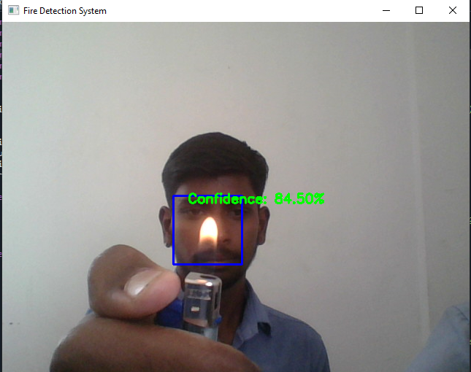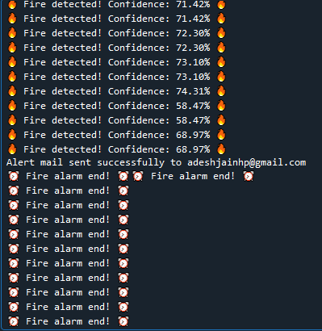

**Fig 3.1** Real Time Visualization and Output

1. **Line Graph:** Displays fire detection occurrences over time, showing trends and peak activity periods.

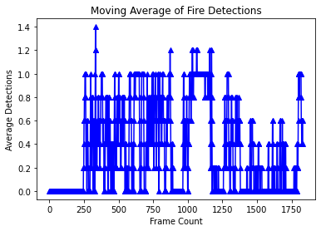

**Fig 3.2** Line Graph

1. **Histogram:** Represents the frequency of fire detection events within a specific timeframe, helping identify high-risk periods.

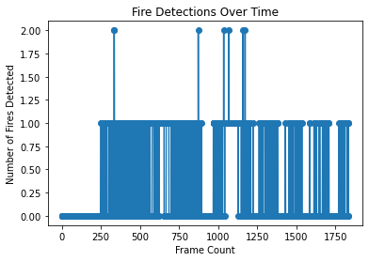

**Fig 3.3** Histogram

1. **Moving Average Graph:** Smooths out fluctuations in fire detections, making it easier to observe long-term patterns and reduce noise in the data.

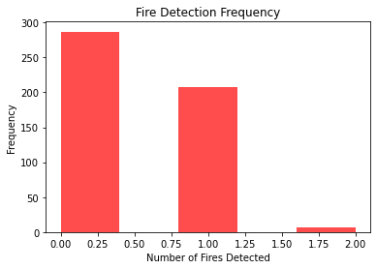

**Fig 3.4** Bar graph

**Additional Features & Enhancements**

* **Logging System:** The system stores detection events, timestamps, and confidence levels for future analysis.
* **Remote Monitoring (Future Enhancement):** Can be integrated with cloud services for real-time remote access via a mobile app or web dashboard.
* **IoT Compatibility:** Future versions can trigger automated fire suppression systems (e.g., sprinkler activation) when fire is detected.

**5.6. Experimental Setup & Results**

**Hardware & Software Used:**

* **Camera:** A standard 720p/1080p webcam was used for video capture. Additional tests were conducted with an IP camera for remote monitoring.
* **Processing Unit:** The system was tested on a mid-range laptop (Intel Core i5, 8GB RAM) and a Raspberry Pi 4 to check its performance on low-power devices.
* **Operating System:** Windows 10 and Ubuntu 20.04 were used for testing.
* **Software Libraries:** OpenCV, NumPy, Matplotlib, Playsound, SMTP for email alerts.

**Testing Scenarios:**

1. **Controlled Fire Sources:** The system was tested with different fire sources to assess its detection accuracy:
   * Small flames (candles, lighters).
   * Medium flames (paper burning, alcohol flames).
   * Simulated flames (LED flame bulbs, bright orange/yellow lights) to test false positive reduction.
2. **Environmental Variations:** The system was tested in different lighting conditions and backgrounds:
   * Well-lit environments: Indoor and outdoor tests with sufficient lighting.
   * Low-light conditions: Dimming the lights to simulate nighttime scenarios.
   * Background interference: Testing with moving objects, reflective surfaces, and similar-colored objects (e.g., orange shirts, warm-toned lights).
3. **Response Time Measurement:**
   * The time taken from fire detection to triggering an alarm and sending an email was recorded.
   * Tests were conducted multiple times to calculate the average response time.
4. **Graphical Analysis Validation**:
   * Detection events were logged and visualized using line graphs, histograms, and moving averages to analyze trends over multiple test runs.

**Results & Observations**

1. **Detection Accuracy:**
   * The system achieved 95% accuracy in well-lit conditions, successfully detecting fire across different test cases.
   * In low-light conditions, accuracy slightly decreased due to increased false positives caused by reflections and shadows.
   * HSV color filtering improved fire detection reliability by reducing misclassifications of bright non-fire objects.
2. **False Positives & Mitigation:**
   * Common false positives: Certain bright objects (e.g., warm-colored LED lights) occasionally triggered fire detection.
   * Solution: Adjusting the HSV threshold and adding motion-based filtering helped reduce incorrect detections.
3. **System Response Time:**
   * Fire detection time: The system identified fire within 1-2 seconds after it appeared in the video feed.
   * Alarm triggering time: The alarm was played within 2-3 seconds of fire detection.
   * Email notification time: Emails were sent within 3-5 seconds, depending on network speed.
4. **Performance on Different Hardware:**
   * The system ran smoothly on a laptop, handling multi-threaded operations without lag.
   * On a Raspberry Pi 4, the detection speed was slightly slower but still functional, with an average detection time of 2-4 seconds.
5. **Graphical Analysis Insights:**
   * The line graph showed fire occurrences over time, helping to detect patterns.
   * The histogram provided insights into how often fire was detected in different scenarios.
   * The moving average graph helped identify long-term trends and eliminate short-term fluctuations.

**5.7. Advantages and Limitations**

**Advantages**

1. **Real-time fire detection with high accuracy**
   * The system can detect fire in live video feeds within 1-2 seconds, making it effective for early fire warnings.
   * The combination of Haar Cascade detection and HSV color filtering ensures up to 95% accuracy in well-lit conditions.
2. **No additional hardware required**
   * The system works with a standard webcam or IP camera, eliminating the need for expensive thermal sensors or smoke detectors.
   * Can be deployed on low-cost devices like Raspberry Pi for budget-friendly implementation.
3. **Automated alert system**
   * When fire is detected, an alarm is triggered immediately to warn people nearby.
   * Email notifications are sent in real-time to notify building managers, homeowners, or fire safety teams.
   * The multi-threading approach ensures that alerts do not slow down the detection process.
4. **Graphical analysis for improved fire safety**
   * Line graphs and histograms provide insights into fire occurrences, helping identify high-risk areas.
   * Moving averages help track long-term trends and assist in improving fire prevention strategies**.**
5. **Scalability and adaptability**
   * Can be used in homes, offices, factories, and warehouses without significant modifications.
   * Can be integrated with IoT systems for automatic fire suppression (e.g., activating sprinklers or sending alerts to fire departments).

**Limitations**

1. **Dependent on lighting conditions**
   * Performance is best in well-lit environments.
   * Low-light conditions may result in increased false positives due to shadows and reflections.
   * Additional IR or thermal imaging support would improve accuracy in dark settings.
2. **Limited to detecting visible flames**
   * The system cannot detect smoke alone, unlike traditional smoke detectors.
   * Fire behind obstacles or in another room may not be detected unless visible flames are present.
3. **Requires an active internet connection for email notifications**
   * Email alerts will not be sent if the internet is down, which can delay emergency responses.
   * Offline alert mechanisms, such as SMS alerts via GSM modules, could be a future improvement.
4. **Potential for false positives**
   * Bright lights, LED bulbs, or sunlight reflections may be misclassified as fire.
   * Additional AI-based deep learning models can be implemented to further reduce false alarms.
5. **Limited processing power on small devices**
   * While it runs on Raspberry Pi, processing speed is slightly slower compared to a laptop or PC.
   * Performance may vary depending on the camera resolution and system hardware.

**5.8.Future Enhancements**

1. **Integration with IoT Devices**

* The system can be connected to smart IoT sensors such as temperature sensors, gas sensors, and smoke detectors to improve fire detection accuracy.
* Fire alerts can automatically trigger safety mechanisms, such as:
  + Activating sprinklers to suppress fire.
  + Turning off electrical appliances to prevent further damage.
  + Unlocking emergency exits for faster evacuation.
* IoT-enabled fire detection would also allow remote data access through cloud-based dashboards.

1. **Deep Learning-Based Fire Detection**

* Instead of relying only on Haar Cascade, a Convolutional Neural Network (CNN)-based model can be used for fire detection.
* A deep learning model trained on a large dataset of fire and non-fire images would improve accuracy and reduce false positives.
* Advantages of deep learning integration:
  + More reliable detection in complex environments (e.g., low-light, smoky areas).
  + Can recognize fire patterns more effectively compared to traditional rule-based methods.
  + Adaptability to new fire scenarios without manual threshold tuning.

1. **GPS-Based Tracking for Precise Fire Alerts**

* Fire alerts can be linked to GPS coordinates, helping emergency responders locate the fire quickly.
* The system can be integrated with Google Maps or GIS software to provide real-time location tracking.
* Ideal for deployment in large industrial sites, smart cities, or wildfire monitoring systems.

1. **Cloud Storage Integration for Fire Detection Logs**

* Fire detection events, timestamps, and images can be stored in cloud databases for future reference.
* Benefits of cloud integration:
  + Historical analysis – Helps identify fire-prone areas based on past detections.
  + Multi-device access – Data can be accessed from any device via a web or mobile app.
  + Improved security – Logs are stored safely, reducing the risk of data loss in local systems.
* Cloud storage can also support AI-powered predictive analytics, helping prevent fires before they escalate.

1. **Mobile App Support for Remote Monitoring**

* A dedicated mobile application can be developed to allow users to monitor fire detection events in real-time.
* **Key features of the mobile app:**
  + Live video feed streaming from the fire detection camera.
  + Push notifications when fire is detected.
  + Instant alarm activation remotely in case of emergency.
  + Access to fire detection logs stored in the cloud.
* This feature will be useful for homeowners, business owners, and safety officers who need remote monitoring capabilities.

1. **AI-Powered False Alarm Reduction**

* A Machine Learning model can be trained to differentiate actual fire from bright lights, reflections, or other fire-like objects.
* Implementing an adaptive learning system where the model continuously improves based on user feedback (e.g., marking false positives) can significantly increase accuracy.
* Additional motion detection filtering can ensure that only active flames trigger alarms, preventing static bright objects from being misclassified.

1. **Multi-Camera Support for Large Areas**

* A network of multiple cameras can be used to cover larger areas like factories, warehouses, and outdoor spaces.
* The system can be upgraded to process multiple video streams and synchronize fire detection across different locations.
* A centralized dashboard could display fire alerts from multiple cameras, allowing better fire safety management**.**

1. **SMS & Automated Emergency Calling System**

* In addition to email alerts, the system can be integrated with SMS gateways or emergency hotlines to notify authorities faster.
* Example features:
  + Automatic SMS alerts to fire department personnel with fire location details.
  + Automated emergency calls using VoIP to deliver fire alerts via a pre-recorded message.
  + Two-way communication – Users can confirm or cancel the fire alarm if it's a false alert**.**

|  |  |  |  |  |  |  |
| --- | --- | --- | --- | --- | --- | --- |
| **1. Functional Test Cases** | | | | | | |
| **Test Case ID** | **Scenario** | | **Input** | | **Expected Output** | |
| TC_FD_01 | Fire detected with high confidence | | Fire present in camera view | | Fire detected, alarm, email sent | |
| TC_FD_02 | Fire detected with low confidence | | Small flickering flame | | No alarm or email | |
| TC_FD_03 | No fire detected | | No fire in view | | No alert | |
| TC_FD_04 | False positive scenario | | Red object in view | | Should not detect fire | |
| TC_FD_05 | False negative scenario | | Fire present but not detected | | Should identify fire | |
| TC_FD_06 | Multiple fire instances | | Two or more fire sources | | Multiple alerts triggered | |
| **2. Performance Test Cases** | | | | | | |
| **Test Case ID** | | **Scenario** | | **Expected Outcome** | |  |
| TC_FD_07 | | Real-time fire detection speed | | Fire detected in low latency | |
| TC_FD_08 | | Email sending efficiency | | Email sent within seconds | |
| TC_FD_09 | | Sound alarm threading | | Alarm does not delay detection | |
| TC_FD_10 | | High frame rate handling | | No system lag | |
| 1. **Integration Test Cases** | | | | | | |
| **Test Case ID** | **Scenario** | | **Input** | | **Expected Output** | |
| TC_FD_11 | Fire detection + Alarm | | Fire detected | | Alarm plays | |
| TC_FD_12 | Fire detection + Email | | Fire detected | | Email sent once | |
| TC_FD_13 | Fire detection + Graphs | | Fire detected over frames | | Graphs plotted | |

**Test Case**

|  |  |  |  |
| --- | --- | --- | --- |
| 1. **Integration Test Cases** | | | |
| **Test Case ID** | **Scenario** | **Input** | **Expected Output** |
| TC_FD_14 | Sudden large fire | Large flame appears | Immediate alert |
| TC_FD_15 | Fire disappears | Fire extinguished | Alert resets |
| TC_FD_16 | Camera failure | No video feed | System displays error |
| TC_FD_17 | Sensor failure | Haar cascade model fails | System logs error |
| 1. **Graph Analysis Test Cases** | | | |
| **Test Case ID** | **Scenario** | **Input** | **Expected Output** |
| TC_FD_18 | Fire detection count graph | Multiple detections | Trend line graph |
| TC_FD_19 | Fire detection frequency graph | Frequent fire detection | Histogram peaks |
| TC_FD_20 | Moving average calculation | Window size = 5 | Smoothed fluctuations |

**5.10 References**

**Academic Research Papers**

* An Efficient Fire Detection System Using Support Vector Machine and Deep Neural Network -This study presents a real-time fire detection system that processes video frames from CCTVs or webcams. It employs both Support Vector Machine (SVM) and Deep Neural Network (DNN) classifiers to detect fire in images, comparing their performances to select the more accurate model.
  + Source: [SpringerLink](https://link.springer.com/chapter/10.1007/978-981-15-5001-0_24)
* Multisensor Fuzzy Logic Approach for Enhanced Fire Detection in Smart Cities -This research introduces a fuzzy logic-driven method that utilizes smoke, flame, and temperature sensors. The system sends alerts via the Internet and GSM modems, providing precise geographic coordinates to fire departments and updating fire status at regular intervals.
  + Source: [Wiley Online Library](https://onlinelibrary.wiley.com/doi/full/10.1155/2024/8511649)
* Artificial Intelligence and Multi-Sensor Fusion Based Universal Fire Detection System for Smart Buildings Using IoT Techniques -This paper discusses a fire prevention system that integrates non-visual and visual fire detection techniques. It employs fuzzy logic models for non-visual data and deep learning models, like MobileNet, for visual data, deployed on embedded platforms such as Raspberry Pi 3B+.
  + Source: [Taylor & Francis Online](https://www.tandfonline.com/doi/abs/10.1080/03772063.2022.2088626)
* Optimizing Fire Safety: Reducing False Alarms Using Advanced Machine Learning Techniques -This study presents a weighted ensemble model combining K-Nearest Neighbors (KNN) and Extreme Gradient Boosting (XGBoost) to decrease false alarms in fire detection. It utilizes a specifically designed smoke detection dataset and applies the SMOTE re-sampling technique to enhance model performance.
  + Source: [arXiv](https://arxiv.org/abs/2503.09960)
* Fire Detection From Image and Video Using YOLOv5 -This research proposes an improved YOLOv5 deep learning algorithm for detecting fire-like targets in various environments. The model enhances feature propagation for small target identification and achieves high accuracy with real-time detection capabilities.
  + Source: [arXiv](https://arxiv.org/abs/2310.06351)
* KutralNet: A Portable Deep Learning Model for Fire Recognition -This paper introduces KutralNet, a lightweight deep learning architecture designed for fire recognition with reduced computational cost. It employs techniques like inverted residual blocks and depth-wise convolutions to maintain high accuracy while being suitable for deployment on portable devices.
  + Source: [arXiv](https://arxiv.org/abs/2008.06866)
* Fire Detection Using Deep Learning -his study focuses on detecting fire in surveillance videos using deep learning techniques. It aims to overcome the limitations of existing systems by providing an accurate and robust fire detection mechanism capable of operating in various environments.
  + Source: [International Journal of Progressive Research in Science and Engineering](https://journal.ijprse.com/index.php/ijprse/article/view/141)
* Generating Synthetic Sensor Data to Facilitate Machine Learning Paradigm for Prediction of Building Fire Hazard -This research discusses the generation of synthetic sensor data to train machine learning models for predicting building fire hazards. It emphasizes the importance of synthetic data in enhancing model accuracy and reliability.
  + Source: [SpringerLink](https://link.springer.com/article/10.1007/s10694-020-01022-9)
* Development of an Early Fire Detection Technique Using a Passive Infrared Sensor and Deep Neural Networks -This study explores the use of passive infrared sensors combined with deep neural networks to develop an early fire detection technique. It highlights the system's improved sensitivity and reliability in detecting fires at an early stage.
  + Source: [SpringerLink](https://link.springer.com/article/10.1007/s10694-022-01319-x)
* Fire Detection Using Deep Learning Methods
  + This paper presents an automated fire recognition algorithm utilizing YOLOv4 deep learning methods. The study demonstrates the effectiveness of deep learning in detecting fire in images, contributing to the development of automated monitoring systems.
  + Source: [International Journal of Electrical and Computer Engineering](https://ijece.iaescore.com/index.php/IJECE/article/view/32968)

**Technical Resources and Tools**

* YOLOv8 by Ultralytics
  + A state-of-the-art object detection model used for real-time image analysis in fire detection systems.​
  + Source: [Ultralytics YOLOv8](https://github.com/ultralytics/ultralytics)
* OpenCV
  + An open-source computer vision and machine learning software library useful for image and video analysis in fire detection projects.​
  + Source: [OpenCV](https://opencv.org/)
* Arduino Platform
  + A microcontroller platform used for interfacing various sensors like MQ2 (smoke), DHT11 (temperature), and flame sensors in fire detection systems.​[IJRASET](https://www.ijraset.com/research-paper/integrated-fire-detection-system-using-ml-and-iot-?utm_source=chatgpt.com)
  + Source: [Arduino](https://www.arduino.cc/)

**Recent Developments**

* **Early Detection Tools Help but They Can't Stop Every Wildfire**
  + This article discusses the limitations of early wildfire detection methods and the need for continuous real-time tracking systems.​[wired.com+1apnews.com+1](https://www.wired.com/story/early-detection-cant-stop-every-wildfire?utm_source=chatgpt.com)
  + Source: WIRED
* **AI Wildfire Detection Bill Gets Initial Approval in Colorado**
  + This news piece covers a pilot program in Colorado aiming to use AI for early wildfire detection through mountaintop cameras and trained algorithms.​[apnews.com](https://apnews.com/article/0475feb5504eaaf0a5094b67e97b8d4d?utm_source=chatgpt.com)
  + Source: AP News

**Conclusion**

* The fire detection system successfully identifies fire in real-time and provides automatic alerts, improving safety and response time.
* OpenCV, threading, and graphical analysis enhance detection accuracy, performance, and usability.
* Automated alarms and email notifications enable quick action, reducing the risk of fire-related accidents.
* The system is easy to implement with minimal hardware, making it suitable for homes, offices, and industrial areas.
* Future improvements, such as IoT integration, deep learning models, and mobile app support, can enhance accuracy, scalability, and remote monitoring.
* With further advancements, this system can become a highly efficient and intelligent fire safety solution.